
Assessment Cover Page

Student Full Name | Huiyan LI
Student Number | 2026466
Module Title | Statistical Techniques
Assessment Title | Statistical Techniques for Data Analysis
Lecturer/Supervisor | Taufique Ahmed
Assessment Due Date | 1/11/2026
Date of Submission | 1/11/2026

GitHub Repository
目录
1.Introduction and Dataset Overview 3
2. Descriptive Statistical Analysis 3
2.1 Dataset Structure and Variable Types 3
2.2 Data Quality and Missing Values 4
2.3 Descriptive Statistics 4
2.4 Data Visualization and Findings 5
3. Binominal and Poisson Distribution 7
3.1 Binomial 7
3.2 Poisson Distribution 9
4. Normal Distribution 11
5. Comparison of Distribution 12
6. Conclusion 13
7. References 14

1.Introduction and Dataset Overview
This study analyzes New York City Yellow Taxi trip records for January 2025(NYC Taxi and Limousine Commission, 2025b). The dataset contains 3,475,226 trip records and 20 raw variables—including pickup and drop-off times, trip distance, passenger count, payment type and fare amount.

The aim is to explore trip patterns using both categorical and numerical variables. Binomial and Poisson distributions are applied to payment outcomes and trip counts, respectively, while the Normal distribution is examined using trip duration. The suitability, assumptions and limitations of these distributions are also critically evaluated. All analyses were conducted in Python using pandas, NumPy, SciPy and Matplotlib (Hunter, 2007; McKinney, 2010; Harris et al., 2020; Virtanen et al., 2020).

2. Descriptive Statistical Analysis

2.1 Dataset Structure and Variable Types
Table 1. Variable Types and Their Applications
Variable | Type | Used in
payment_type | Categorical (nominal) | Task 1, Binomial
PULocationID | Categorical (nominal) | Task 1, Poisson
passenger_count | Discrete numerical | Task 1
Pickups per minute (derived) | Discrete numerical (count) | Poisson
trip_distance, fare_amount | Continuous numerical | Task 1
duration_min (derived) | Continuous numerical | Task 1, Normal

The dataset contains two categorical variables and five numerical variables, meeting the requirements for this assignment.

Although payment_type has multiple categories, credit card and cash payments are selected as two outcomes for Binomial analysis, per minute pickup counts and trip duration are derived from the original timestamps and used for Poisson modeling and Normal distribution analysis, respectively with the suitability of these models assessed later.

2.2 Data Quality and Missing Values
Missing-value checks identified five variables (passenger_count, RatecodeID, store_and fwd_flag, congestion_surcharge and Airport_fee), each with 540,149 missing values (15.54%). These visible data-quality issues occurred in exactly the same rows, all corresponding to payment_type = 0 (flex fare)(NYC Taxi and Limousine Commission, 2025a), suggesting a systematic missingness pattern.

This study adopts the available-case approach for handling missing values, rather than deleting entire records or imputing missing data. Imputation could introduce artificial values, while the pickup times in these records remain usable for counting pickup events in the Poisson analysis.

Further checks identified potential data-quality issues: 90,893 zero-distance trips, 2,051 non-positive durations and 145,516 non-positive fares. One record reported approximately 276,423 miles travelled in nine minutes, a physically impossible journey.

For descriptive analysis, trip with positive distances up to 100 miles, positive durations up to 180 minutes and positive fares up to $500 were retained. These thresholds define the study range rather than official validity rules. Filtering retained 3,251,034 records (93.55%).

2.3 Descriptive Statistics
All three numerical variables show strong positive skewness, with means exceeding medians and skewness > 1. This suggests that relatively long or expensive trips pull the averages upwards, so the median better characterizes typical trips.

After filtering, the standard deviation of trip distance falls considerably from 564.60 to 4.14 miles, demonstrating the strong influence of extreme observations.

Credit card payments account for 74.52% of filtered trips, followed by Flex Fare (12.71%) and cash (11.30%). Passenger_counts were available for 2,837,879 of the 3,251,034 selected trips because the remaining Flex Fare records omit this information.

While filtering removed major anomalies, a minimum passenger count of zero and extremely short trip duration remained, highlighting the limitations in the applied thresholds.
Table 2. Descriptive statistics of selected taxi trips
Statistic | Distance (miles) | Duration (minutes) | Fare ($)
Mean | 3.17 | 14.67 | 17.94
Median | 1.70 | 11.68 | 12.80
Standard deviation | 4.14 | 11.34 | 16.20
Skewness | 3.17 | 2.49 | 3.61

2.4 Data Visualization and Findings
Figure 1. Trip Distance Histogram
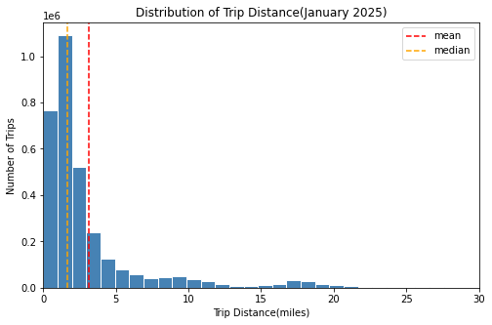

Histograms are used to examine the distribution of trip distance. Most trip are concentrated at shorter distance, with a long right tail, confirming the positive skewness, with the mean exceeding the median, suggesting that longer trips increase the average distance. A secondary peak around 15-20 miles may reflect airport-related journeys, although further analysis of pickup and drop-off locations is required to confirm this.

The boxplot in Figure 2 is selected to show the median, quartiles and potential outliers. The middle 50% of fares range from $8.60 to $19.80, with numerous high-value outliers. These outliers may represent genuine long-distance or airport trips and should not be automatically removed.

Figure 2. Fare Amount Boxplot (display range:$0—$100 )
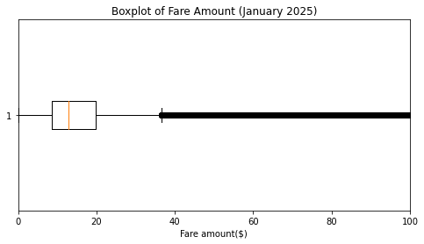

A bar chart in Figure 3 compares payment types, which are categorical variables. Credit card payments dominate (74.5%), followed by Flex Fare (12.7%) and cash (11.3%); remaining categories account for less than 2% of observations. Restricting the data to credit card and cash payments yields two outcomes, providing the basis for the binomial analysis.

Figure 3. Payment Type Bar Chart
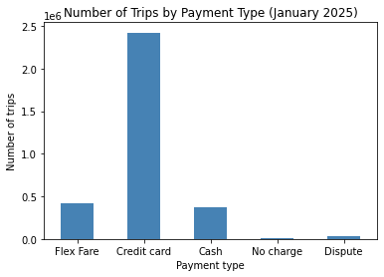

3. Binominal and Poisson Distribution

3.1 Binomial
Let X be the number of credit card payments in 20 randomly selected trips paid by either credit card or cash.

Model assumptions: each trip has two possible payment outcomes. Trips are assumed independent, with a constant probability of credit card payment:
$$p=\frac{2,422,685}{2,790,204}≈0.8683$$

$$X∼ B(20, 0.8683)$$

The Binomial probability formula is:
P(X=k) =$\frac{n!}{k!\left(n-k\right)!}p^{k}{(1-p)}^{n-k}$
For exactly 15 credit probability formula is:
$$\left({20 \atop 15}\right)=\frac{20!}{15!×5!}=15504$$
$$\begin{aligned}P\left(X=15\right)&=\left({20 \atop 15}\right){\left(0.8683\right)}^{15}{\left(0.1317\right)}^{5} \\ &≈0.0739=7.39\%\end{aligned}$$

The probability of at least 15 credit card payment is:
$$P\left(X≥15\right)=1-P\left(X≤14\right)≈0.9609=96.09\%$$
Thus, the model estimates a 96.09% probability of a least 15 credit card payments among 20 selected trips.

Figure 4 shows a left-skewed distribution when n=20 because p is close to 1. In figure 5, increasing n to 200 produces a more symmetric, bell-shaped distribution. For n= 200, np=173.66 and n(1-p) = 26.34, both exceeding the common threshold of 10, supporting a normal approximation. However, n = 20 does not meet this guideline because n(1-p) = 2.63.

Figure 4: B (20, 0.8683) Figure 5: B (200, 0.8683)
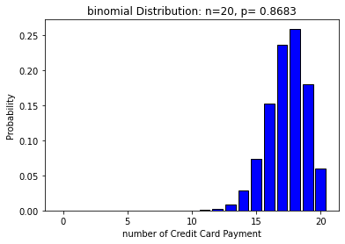 | 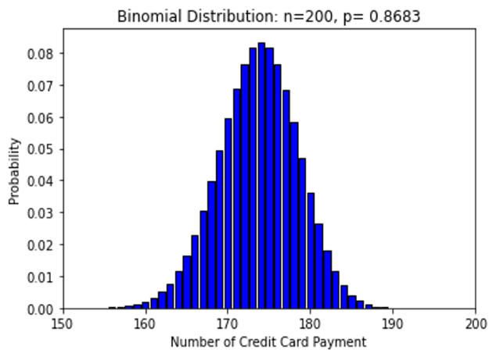
The independence and constant-probability assumptions may not fully hold, as passengers’ payment preferences can be correlated within the same time periods or locations.

3.2 Poisson Distribution
Let X represent the number of recorded taxi pickups per minute in Zone 161 during weekdays from 10:00 to 10:59 in January 2025. The original dataset was used to count pickup events, as a pickup remains a valid event even when its fare or distance is recorded incorrectly. This gives 4,824 pickups across 1,380 minutes.

The Poisson model assumes independent events occurring at a constant average rate within fixed time intervals. Restricting the location and time reduces potential variation in pickup rates.

The estimated parameter was $λ=\frac{4824}{1380}=3.4957$ pickups per minute.

Using the Poisson formula:
$$P\left(X=k\right)=\frac{e^{(-λ)}λ^{k}}{k!}$$
$P\left(X=3\right)=\frac{e^{-3.4957}×{3.4957}^{3}}{3!}≈$0.2159

This matches the SciPy calculation result (21.59%).

The observed variance (4.1109) exceeded the mean (3.4957), indicating mild overdispersion. Figure 6 shows broadly similar theoretical and observed distributions, although observed frequencies are higher at 0, 1, 6 and 7 pickups.

Figure 6. Poisson Model vs Observed Pickup Frequencies
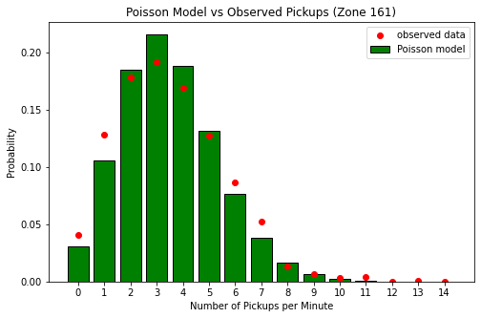
Figure 7 shows that increasing the observation interval to 10 minutes raises $λ$ to approximately 35, producing a more symmetric distribution; the theoretical skewness decreases from 0.53 to 0.17, supporting a normal approximation for larger $λ$.

Figure 7. Poisson Distribution: Small vs Large Lambda
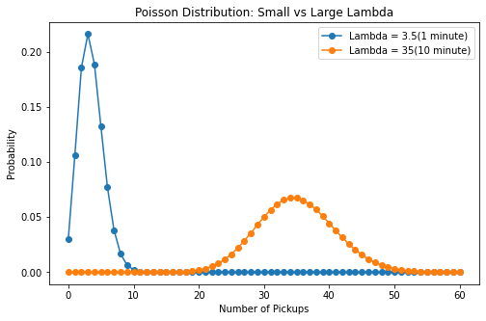
However, pickup rates may vary between days due to factors such as holiday or weather, undermining the constant-rate assumption.

4. Normal Distribution
Trip duration(duration_min) was chosen as the continuous variable to evaluate its conformity to a normal distribution. Following data filtering, the mean trip duration was 14.67 minutes, with a standard deviation of 11.34 minutes and skewness of 2.49, signaling substantial right skewness. Figure 8 shows the distribution peaks at 7-9 minutes, below the mean value, alongside a long right tail. The symmetric normal curve provides a poor fit to the empirical data.
Figure 8. Original Duration
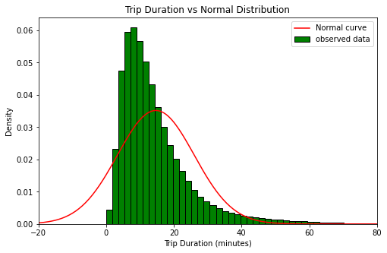

By the 68-95-99.7 rule, roughly 68%, 95% and 99.7% of observations under a normal distribution lie within one, two and three standard deviations of the mean. The observed proportions were 84.47%, 95.35% and 97.90%, respectively. Approximately 2.10% of trips fell beyond three standard deviations—nearly eight times the normal expectation of 0.27%. Although the two-standard-deviation proportion was similar, this alone does not establish normality.

Additionally, the fitted normal model yields a 9.79% probability of zero or negative trip durations, which are not possible in the cleaned dataset.

A natural logarithm transformation reduced skewness from 2.49 to -0.44. Figure 9 presents a more symmetric distribution that aligns better with the fitted normal curve. This indicates trip duration may follow an approximate log-normal distribution, albeit with residual discrepancies.
Figure 9. Log-Transformed Duration
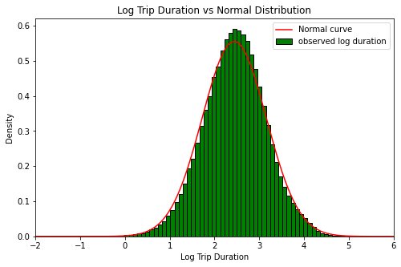

Overall, the median (11.68 minutes) better represents a typical trip than the mean. Where approximate normality is needed, modelling on the log scale is preferable.

5. Comparison of Distribution
The choice of distribution depends on the variable’s characteristics. The binomial distribution models the count of payments from a fixed set of credit-or-cash trips, while the Poisson distribution describes pickup events within fixed time intervals. Normality was examined for the continuous trip duration variable.

For the binomial distribution, a normal approximation generally requires np$≥$10 and n(1-p)$≥$10. When n=20, n(1-p) = 2.63, so the condition is not met and Figure 4 is left-skewed. When n=200, n(1-p) = 26.34, and figure 5 shows a clear bell shape, supporting the approximation.

For the Poisson distribution, increasing $λ$ from 3.5 to 35 skewness (1 /√ λ) from 0.53 to 0.17, supporting a normal approximation.

These findings show discrete distributions can converge to a normal form given sufficiently large n or $λ$. By contrast, continuous variables are not automatically normally distributed: raw trip duration is strongly right-skewed prior to log transformation. Accordingly, distribution shape and model assumptions carry greater importance than a variable’s discrete or continuous nature. Exact binomial or Poisson calculations are preferred whenever precise probabilities are needed.

Table 3. Comparison of variables and suitability of normal approximation
Variable | Type | Distribution | Parameters | Normal approximation
Credit-card payments in n trips | Discrete | Binomial | n=20, p=0.8683 | n=20: No; n=200: Yes, approximately
Pickups per minute | Discrete | Poisson | λ=3.50 | λ=3.5: Poor; λ≈35: Reasonable
Trip duration | Continuous | Normal (tested) | μ=14.67, σ=11.34 | Raw: Poor; log-transformed: Closer

6. Conclusion
This analysis demonstrates how different probability distributions can describe taxi payment behavior, pickup counts and trip duration. Binomial and Poisson models provide useful approximate probability estimates, while the normal analysis reveals substantial right skewness in trip duration that is reduced by a log transformation. The findings underline the importance of selecting distributions according to variable characteristics, verifying assumptions and acknowledging model limitations.

7. References
Harris, C.R. et al. (2020) ‘Array programming with NumPy’, Nature, 585(7825), pp. 357–362. Available at: https://doi.org/10.1038/s41586-020-2649-2.
Hunter, J.D. (2007) ‘Matplotlib: A 2D Graphics Environment’, Computing in Science & Engineering, 9(3), pp. 90–95. Available at: https://doi.org/10.1109/MCSE.2007.55.
McKinney, W. (2010) ‘Data Structures for Statistical Computing in Python’. Python in Science Conference, Austin, Texas, pp. 56–61. Available at: https://doi.org/10.25080/Majora-92bf1922-00a.
NYC Taxi and Limousine Commission (2025a) ‘Data Dictionary – Yellow Taxi Trip Records’. Available at: https://www.nyc.gov/assets/tlc/downloads/pdf/data_dictionary_trip_records_yellow.pdf (Accessed: 27 October 2026).
NYC Taxi and Limousine Commission (2025b) TLC Trip Record Data TLC. Available at: https://www.nyc.gov/site/tlc/about/tlc-trip-record-data.page (Accessed: 27 October 2026).
Virtanen, P. et al. (2020) ‘SciPy 1.0: fundamental algorithms for scientific computing in Python’, Nature Methods, 17(3), pp. 261–272. Available at: https://doi.org/10.1038/s41592-019-0686-2.

